[Enable Basic Authentication For RESTful Web-service | Medium](https://shashanksrivastava.medium.com/enable-basic-authentication-for-restful-web-service-2bd15f4384ba)

In this post, I will show you how you can secure the same API using **Basic Authentication**. With Basic Authentication, you’ll be able to add or retrieve your To-Do’s (*data*) only after entering valid credentials.

*Please note that these steps are based on****Apache/2.4.34****running on****macOS Mojave 10.14.5****. Depending on your OS, your steps might vary slightly.*

**Steps to perform**

**1. Create/edit**.htaccess**file.**

If you have copied or cloned my [GitHub repo](https://github.com/shashank-ssriva/REST-To-Do) (*as discussed in my*[*last post*](https://shashanksrivastava.medium.com/create-a-rest-api-using-php-mysql-60ba1ad918d2)), you will find an .htaccess file there at the root of the project.

If not, start with creating this file (*at the root of your project*).

RewriteEngine On *# Turn on the rewriting engine*RewriteRule ^info/**([**a-zA-Z_-**]**\***)**$ info.php?task**=**$1 **[**NC,L**]**  
AuthType Basic  
AuthName "Restricted Content"  
AuthUserFile /etc/apache2/.htpasswd  
Require valid-user

As you can see above, I am specifying the AuthType & a credentials file /etc/apache2/.htpasswd. After saving this file, follow the next step.

**2. Create/edit your**etc/apache2/.htpasswd**file.**

If you haven’t created this file before, create it first. Below is how to do it.

root@shashank-mbp /U/a/S/REST-To-Do# htpasswd -c /etc/apache2/.htpasswd admin  
New password:

Here, admin is the username which will be used to add/retrieve your To-Do's. Feel free to create any user.

Now enter the password twice. It will create the/etc/apache2/.htpasswd file for you with the credentials to access your API.

*If this file already exists, omit the -c parameter in the above command. -c stands for****creating****the file.*

**3. Test your API**

Now try to GET or retrieve your To-Do info using either a browser or a REST client such as [Postman](https://www.getpostman.com/). In the case of the browser, it will ask you to enter credentials when you enter the REST endpoint in the address bar. See the image below.

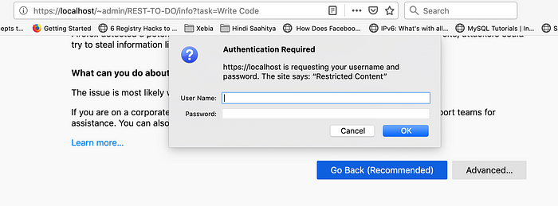

Enter the username/password you specified while creating the .htpasswd file. If your credentials are correct, you'll be able to access the API now.

**If you’re using Postman, you might receive an error like below.**

<!DOCTYPE HTML PUBLIC "-//IETF//DTD HTML 2.0//EN">  
<html>  
 <head>  
 <title>401 Unauthorized</title>  
 </head>  
 <body>  
 <h1>Unauthorized</h1>  
 <p>This server could not verify that you  
are authorized to access the document  
requested. Either you supplied the wrong  
credentials **(**e.g., bad password**)**, or your  
browser doesn't understand how to supply  
the credentials required.</p>  
 </body>  
</html>

It means you need to enable authentication in Postman to access your API. For this, select **Basic Auth** from the **TYPE** dropdown & enter your username/password. After this, click the **Send** button. You’ll see your information in the bottom pane now.

Check the below screenshot for more information.

